**Breweries Test - Documentation**

**NAME:** Breweries Test - Documentation

**TYPE:** Documentation

**DESCRIPTION:** Instructions how to use

**AUTHOR:** Matheus Bosco

**History**

| **Date** | **Version** | **Comments** |
| --- | --- | --- |
| 18/04/2024 | 1.0 | Document Created |
|  |  |  |
|  |  |  |

**Objective**

The goal of this test is consuming data from an API, transforming and persisting it into a data lake following the medallion architecture with three layers: raw data, curated data partitioned by location, and an analytical aggregated layer.

**Source**

The Source for this test is an api that can be consumed via the endpoint: <api.openbrewerydb.org/breweries> . In this api there is data about breweries of different types and different locations, the file is in json format and has the following schema:

schema = {

        "id": str,

        "name": str,

        "brewery_type": str,

        "address_1": str,

        "address_2": str,

        "address_3": str,

        "city": str,

        "state_province": str,

        "postal_code": str,

        "country": str,

        "longitude": str,

        "latitude": str,

        "phone": str,

        "website_url": str,

        "state": str,

        "street": str

 }

**Solution**

To complete the test, the solution was developed in 3 different steps, each step is an airflow dag.

1. **ExtractApi**

This step was built to read data from the api using the python requests library, transform this data into a dataframe using pandas and write it in “bronze” layer of the datalake, keeping the original schema and json format properties.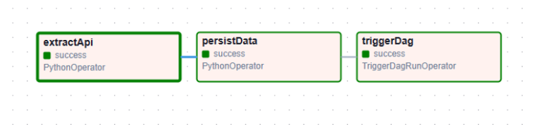

1. **PartitionLocation**

After completing the previous step, the data is read from the bronze layer transformed into a dataframe by pandas, applying a fixed schema. For partitioning issues, a column called “dt_process” was added indicating the date on which the data was processed. After these transformations, the dataframe is converted to parquet type and saved in the “silver” layer, partitioned respectively by: “dt_process”, “country”, “state” and “city”.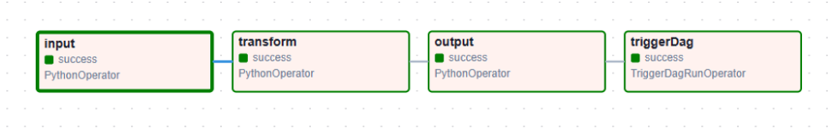

1. **AggData**

In this last step, the data in parquet format is read from the silver layer by pandas and the view construction process begins. The first view called “GroupByType” shows the number of breweries aggregated by type. The second is called “GroupByLocation”, it shows the number of breweries aggregated by region, Country, state and city respectively.

After the transformations, the data is saved in parquet format in the “gold” layer of the datalake, partitioned by date and type of view.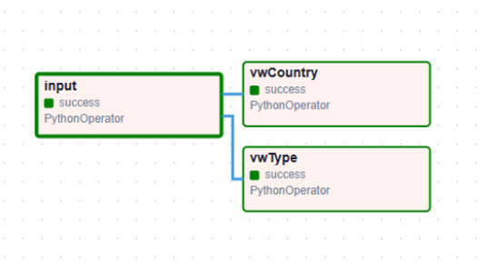

**How to execute**

1. First of all it’s necessary complete the steps in: **docs/ Setup.docx**
2. After starting the environment, there will be a panel called “Dags”, you must enable the following dags: **dagExtract, dagPartition, dagAggregations**

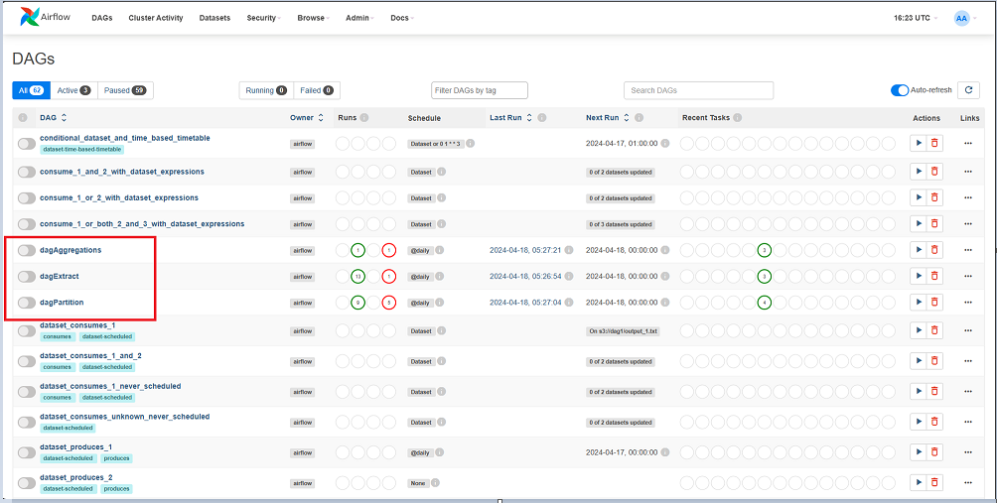With **just these three** dags active, your “active” panel should look like this: 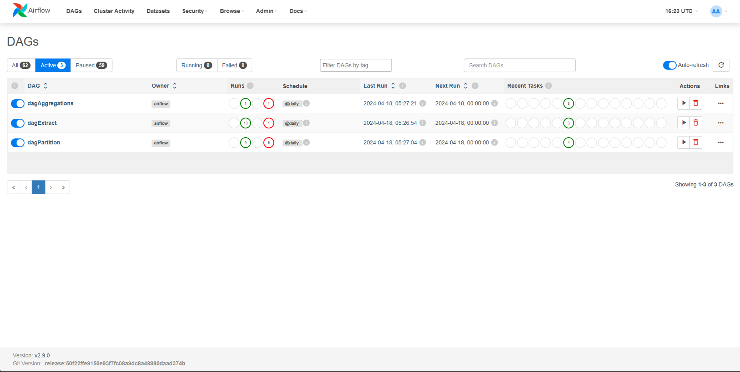

1. After activation, you can wait for the scheduled time in airflow or run the dag manually, just click on the dagExtract Run icon. This dag when executed will automatically execute the next dagPartition**.**

Clicking on dagExtract, you will be able to view a panel with the status of each task, as shown below: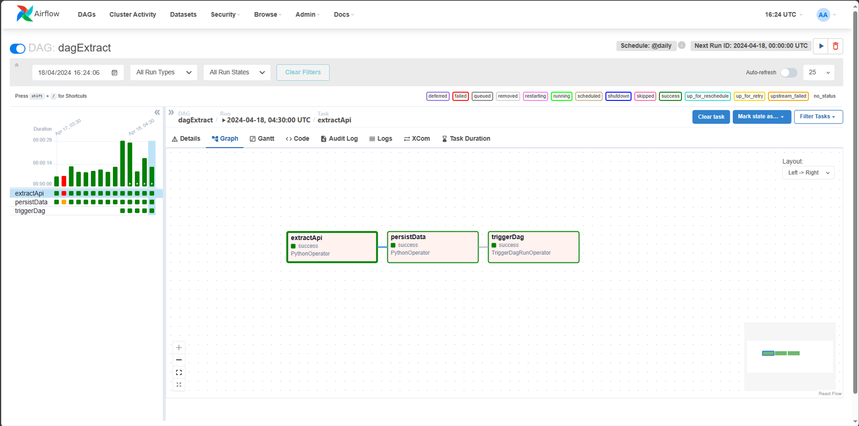

You can also view the logs: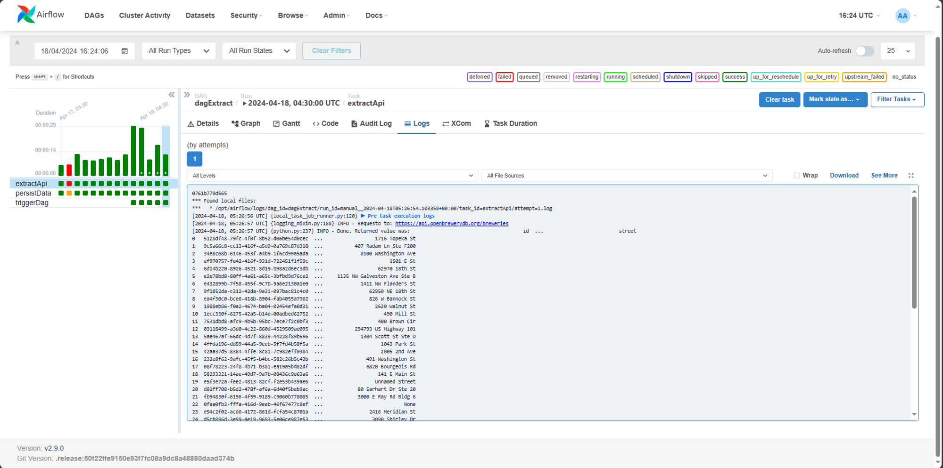

In case of errors, go to the “Graph” tab, click on the first ExtractApi task, clear task and run it again.

The result in the datalake should be the following in case of success: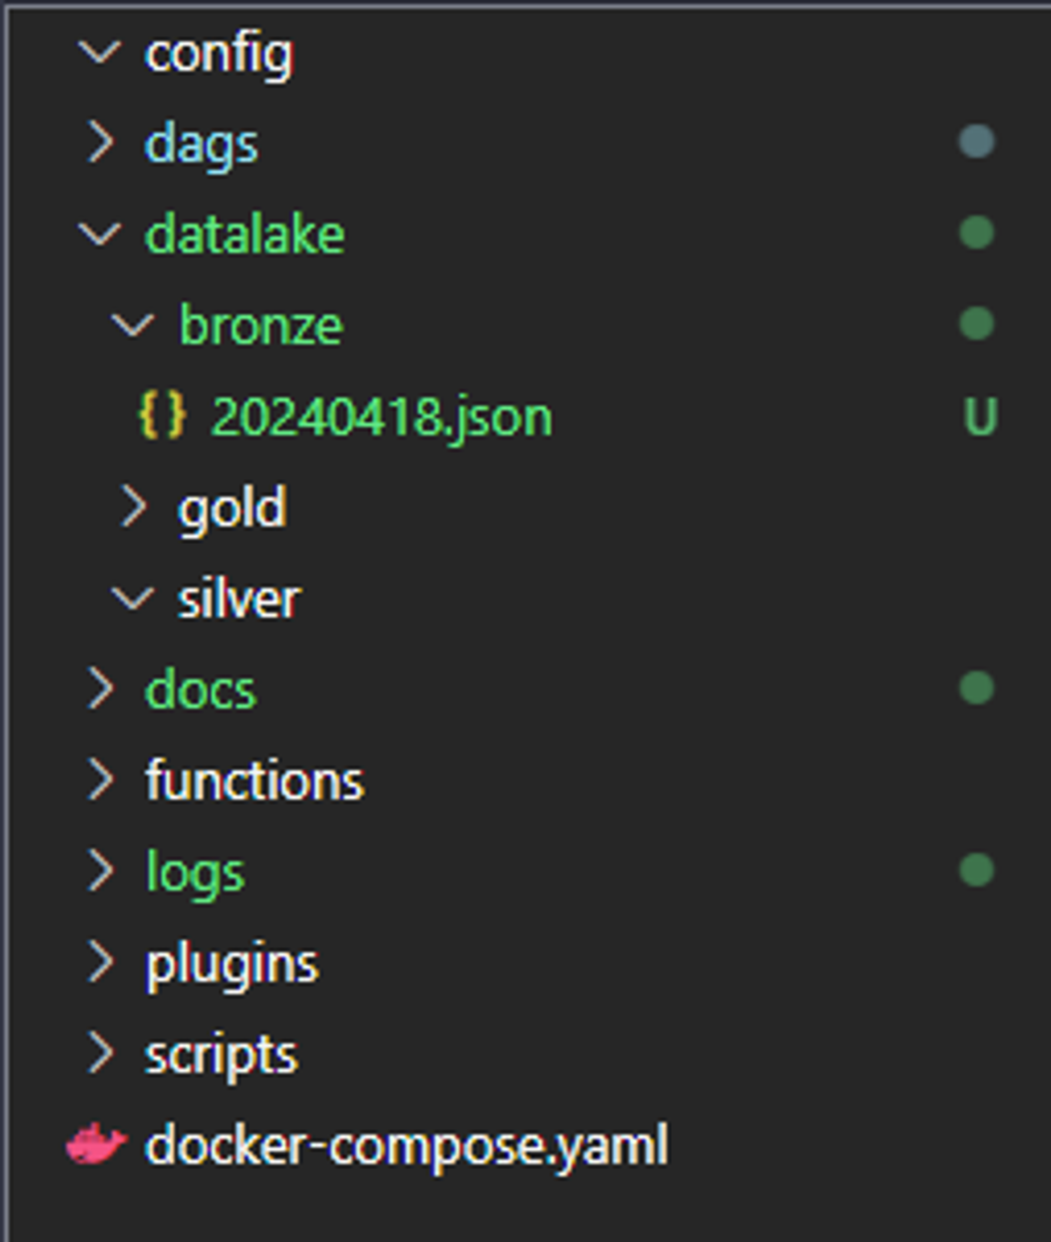

1. After the first step is completed, just check if the other dags executed automatically after the first.

The results should be as follows:

Sucess on **dagPartition**

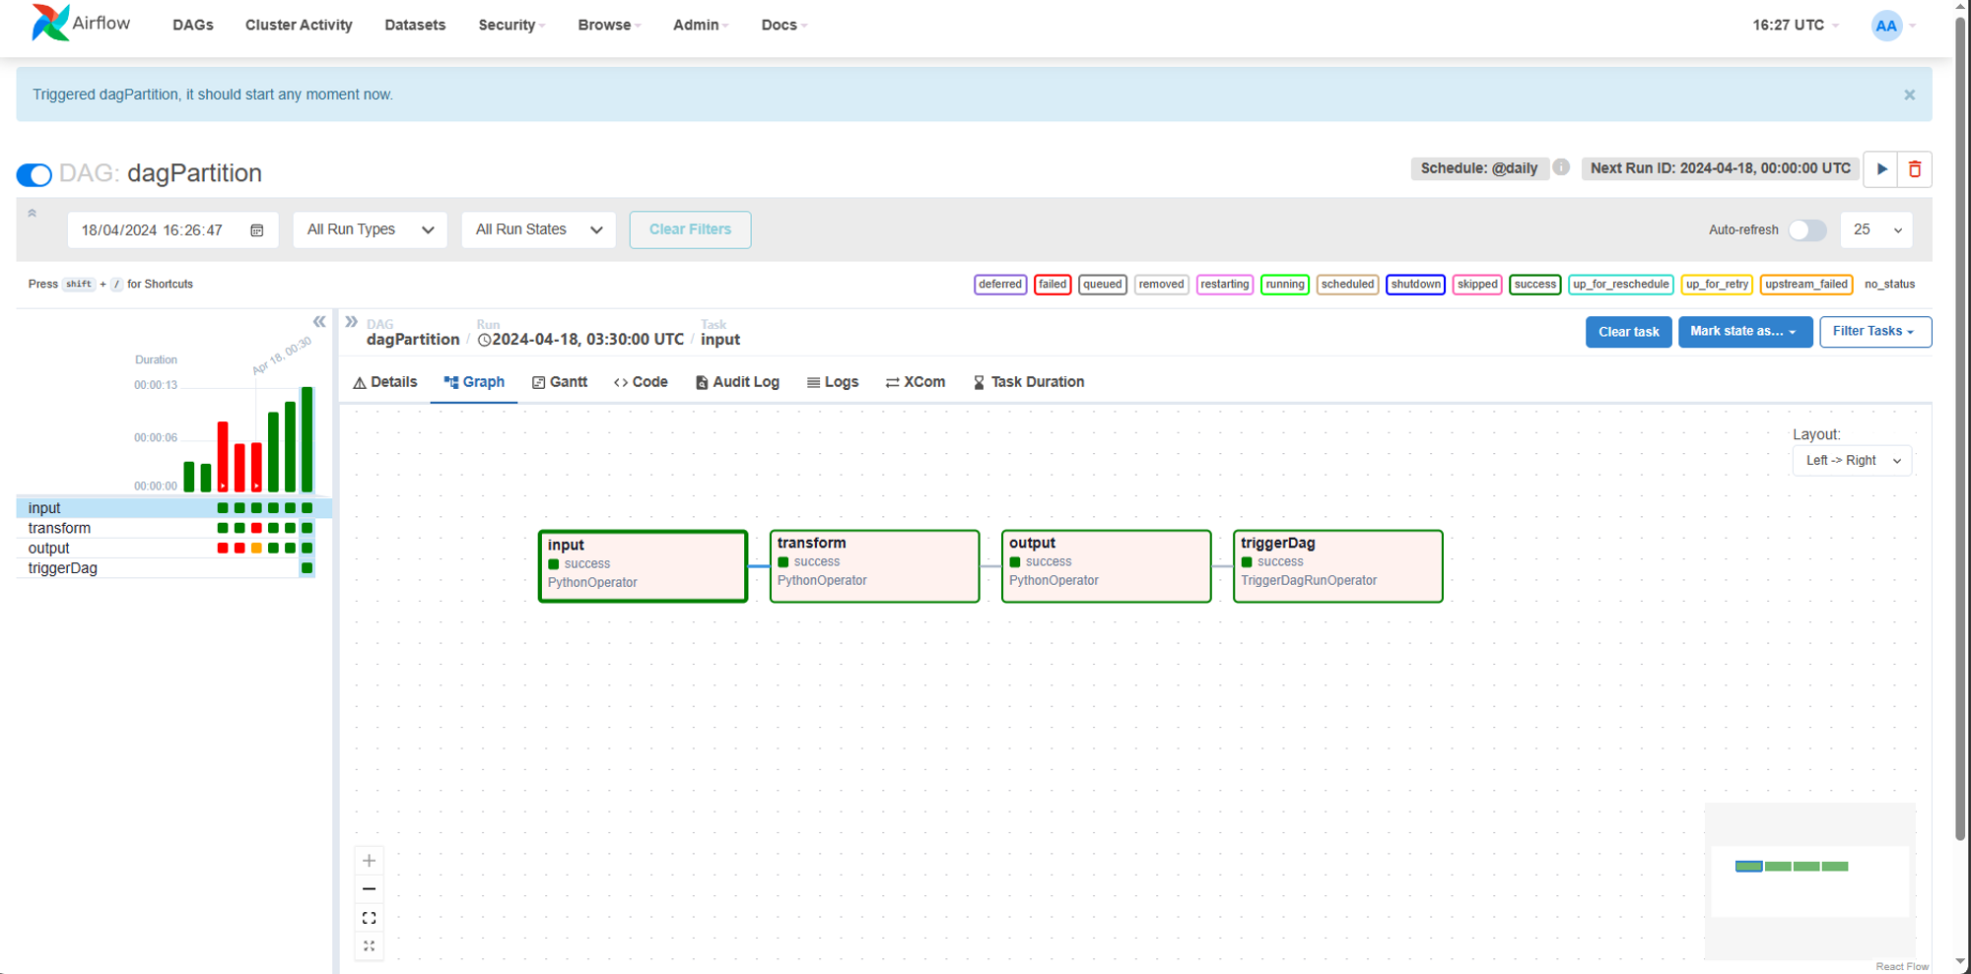

On datalake:

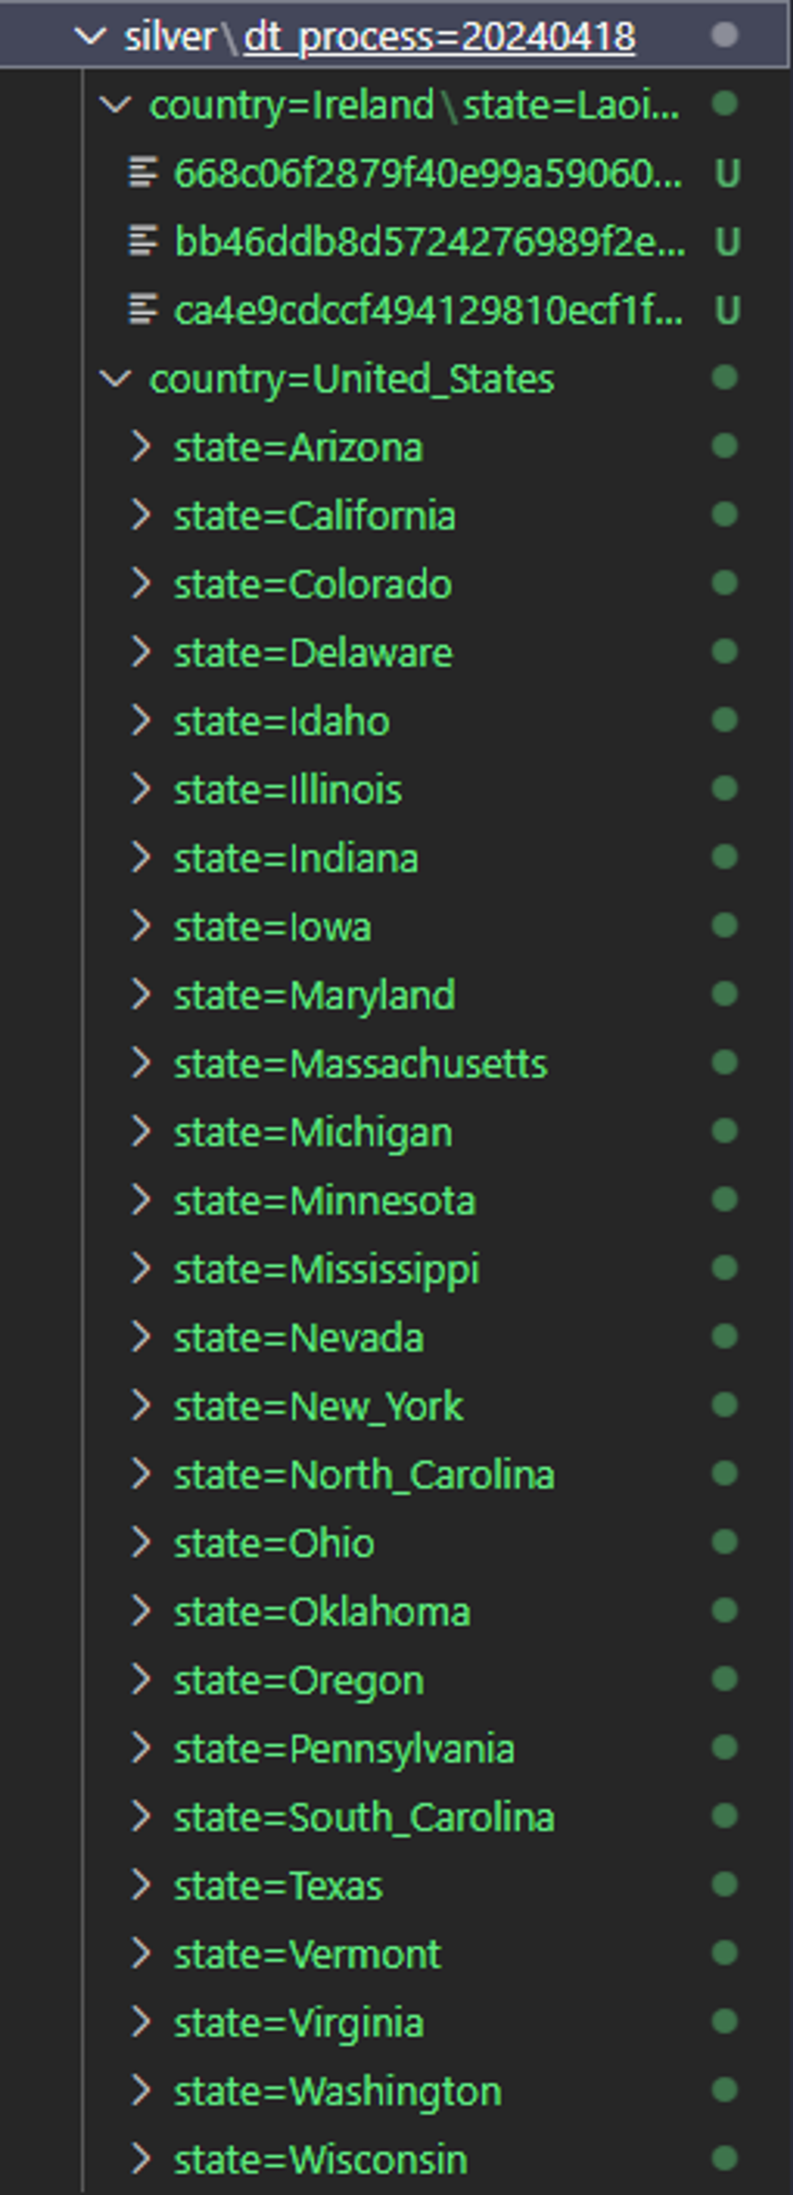

Sucess on **dagAggregations:**

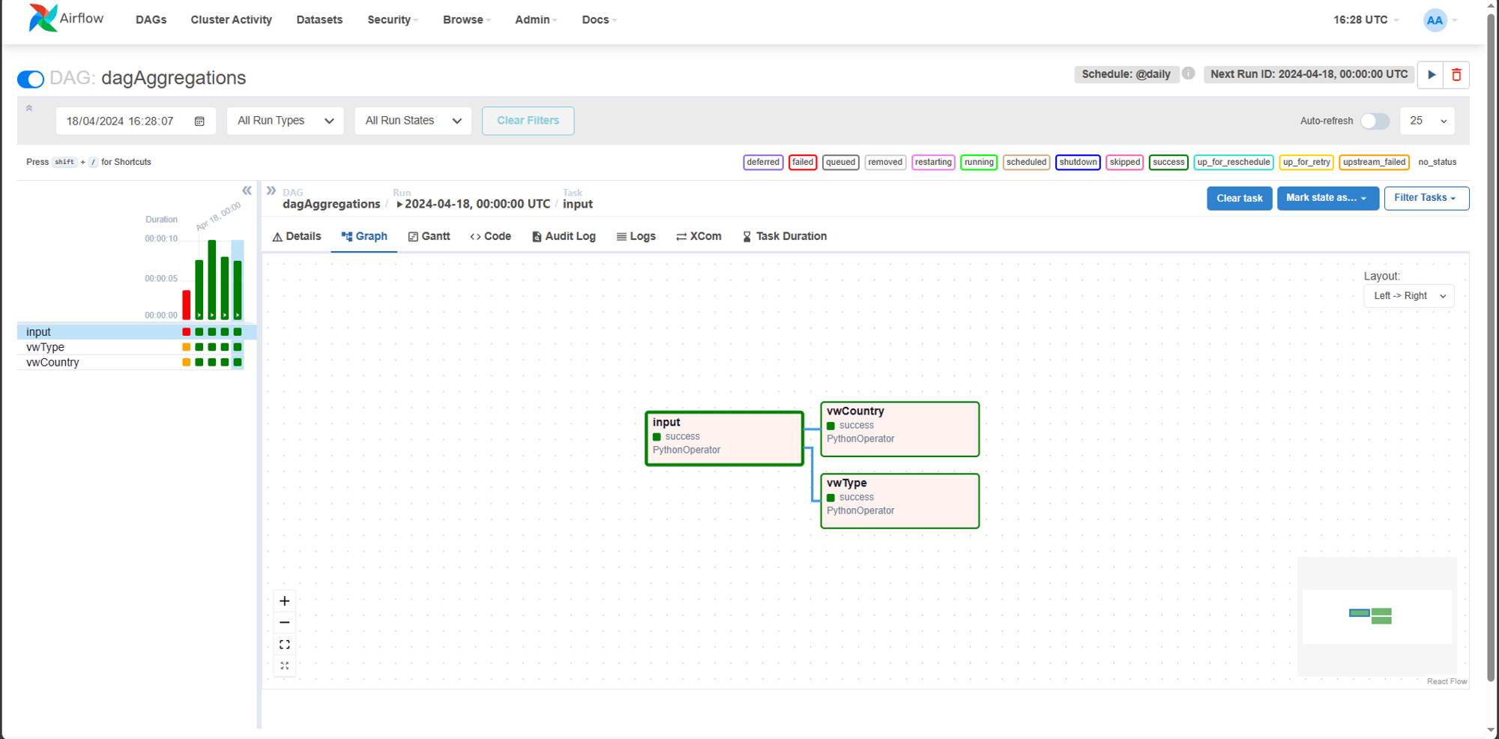

On datalake:

